

|  |
| --- |
| Cost of Living Visualizations Critique |
|  |
| March 24 2023  Student Name: Nguyen Nam Tung  Student ID: 103181157  Subject: Data Visualization COS30045  Word count: 2300 |

# Executive Summary

This report focuses on critiquing three different cost of living visualizations. This paper's chart includes a map, a bar chart, and a combination of a line graph and a stacked bar chart. After an in-depth analysis of the diagrams, it was determined that all of them had design issues that needed to be resolved. The solutions to those problems are also provided in this article.

# Table of content

1. Executive Summary 2

2. Table of content 2

3. Introduction 3

4. Visualizations Critique 3

4.1. Visualization 1: Numbeo cost of living map 3

4.1.1. Context 3

4.1.2. Visual analysis 4

4.1.3. Critique 5

4.1.4. Suggestion 8

4.2. Visualization 2: A breakdown of the rising cost of living in UK 10

4.2.1. Context 10

4.2.2. Visual analysis 10

4.2.3. Critique 12

4.2.4. Suggestion 12

4.3. Visualization 3: CPI inflation rate in UK 13

4.3.1. Context 13

4.3.2. Visual analysis 14

4.3.3. Critique 15

4.3.4. Suggestion 16

5. Conclusion 17

6. Reference 17

# Introduction

This report will examine three distinct cost of living data visualizations. The first graph is a map depicting the cost of living in major cities across the world. The second chart provides a breakdown of the minimum cost of living in the United Kingdom for two years, 2021 and 2022, while the third shows how the Consumer Price Index (CPI) inflation rate, which determines living expenses, has changed from August 2020 to August 2022 in the UK. Members of the general public can easily read and perceive the first and second visualizations. However, the third graph uses economic terminology, which may be confusing to those who are not business specialists. Therefore, viewers should be made aware of the jargon used in those visualizations, which is Consumer Price Index (CPI). CPI measures the change in consumer prices based on products and services over a period of time (Fernando, 2023). CPI is one of the most widely used indicators of inflation, which is defined as the rise in the prices of goods and services that determines the overall cost of living.

# Visualizations Critique

## Visualization 1: Numbeo cost of living map

### Context

The first visualization comes from a website called Numbeo, which depicts the level of living expenditures in numerous cities in the world (Figure 1). This visualization was created for general web users, particularly those who are deciding where to reside in the future.

Figure 1: Numbeo website (*Numbeo*)

### Visual analysis

Here is how the overall visualization appears: (Figure 2)

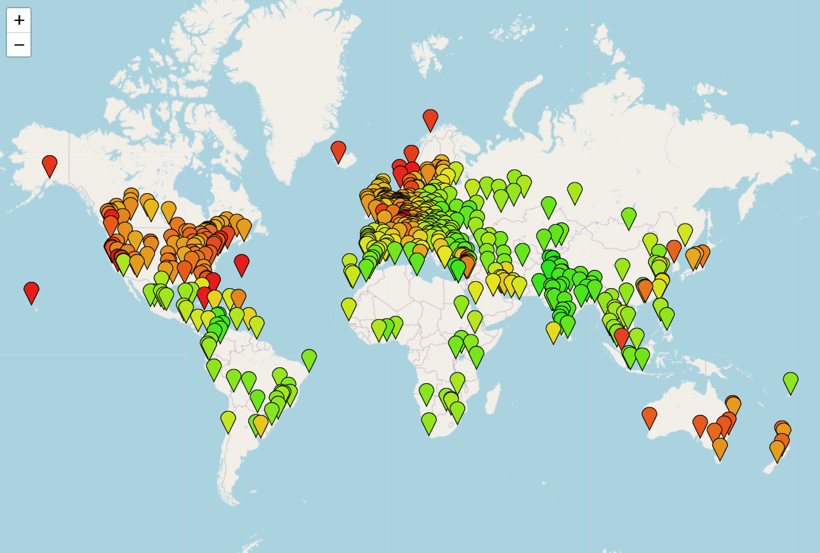

Figure 2: Cost of living map visualization

This map is a scatter plot containing data points representing cities across the world, with their x and y coordinates depicting the cities' longitudes and latitudes. The living expenditure level is represented as interval data on a color scale from green to red, with green representing the lowest level and red representing the highest. (Figure 3)



Figure 3: Numbeo living costs scale

### Critique

The color scale feature has been implemented very effectively, and it plays a crucial role in helping web viewers understand the content of the map. For instance, they can easily distinguish between regions with a high cost of living, such as Europe, North America, and Australia, and areas with a low cost of living, such as Africa and Asia.

Regarding the color of the map, the choice of coloring is also very appropriate. It displays a high degree of contrast between the value of each data point so that color-blind readers are able to differentiate between them.

The map just shows the overall level of living expenses. If the readers want to obtain detailed data about a city, Numbeo has a very interesting interactive feature that allows them to do so. They can zoom in or zoom out of the visualization by clicking the plus and minus buttons in the upper left corner of the map (Figure 4) and dragging the mouse pointer to the desired locations.

Figure 4: Zooming feature of Numbeo

For instance, if I want to see more information about Melbourne, I can zoom in and click on the Melbourne data point on the map. It then shows which country the location belong to and its average cost of living.

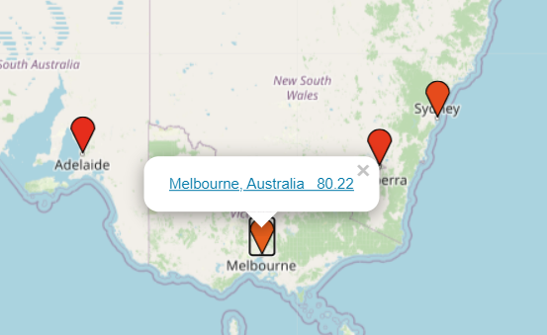

Figure 5: Melbourne data point in Numbeo Visualization

If I click on the figure again, the detailed result will also be displayed. Numbeo also enables users to compare the costs of living and search for information about their desired cities. This feature is very beneficial for web users who want to conduct in-depth cost of living analyses.

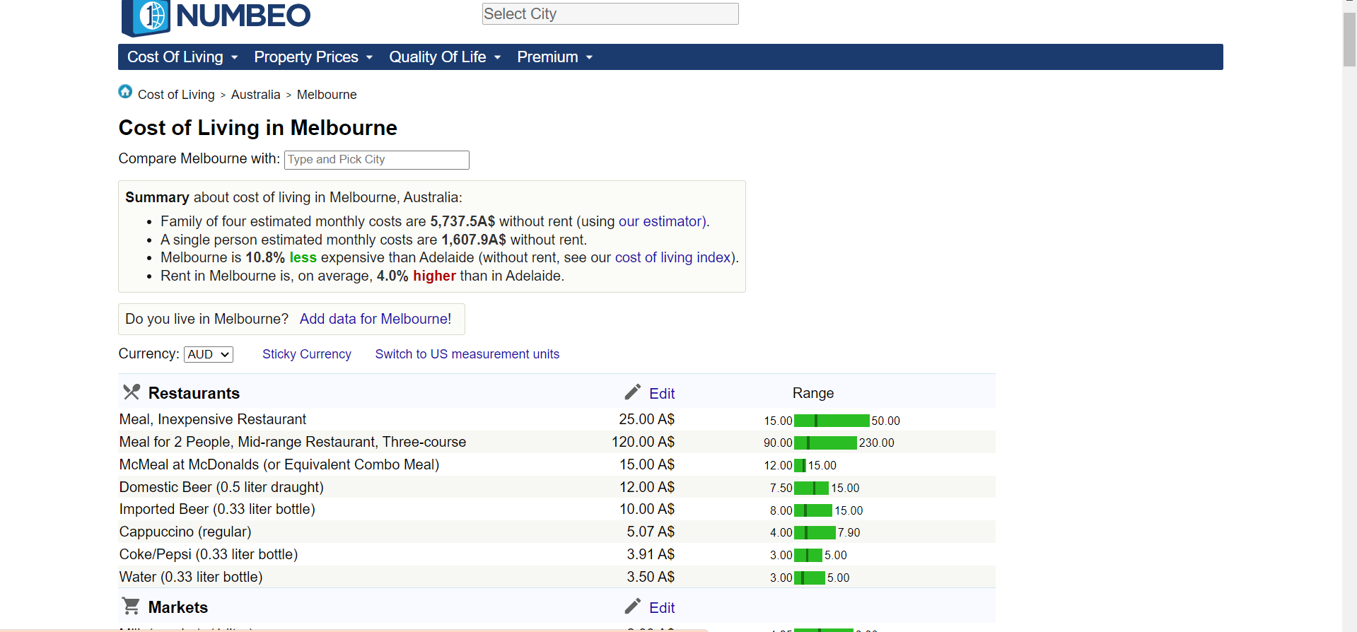

Figure 6: Detailed cost of living in Melbourne of Numbeo

The projection and the layout of the map is also an element that we can compliment. The sizes of the countries and continents are proportionate and balanced relative to the original scale, and the map is not excessively distorted.

However, besides the amazing features, this visualization still has some weaknesses. Firstly, in dense regions such as Europe and North America, it is difficult for users to clearly see and select the desired location because the location points are so close to one another. (Figure 7)

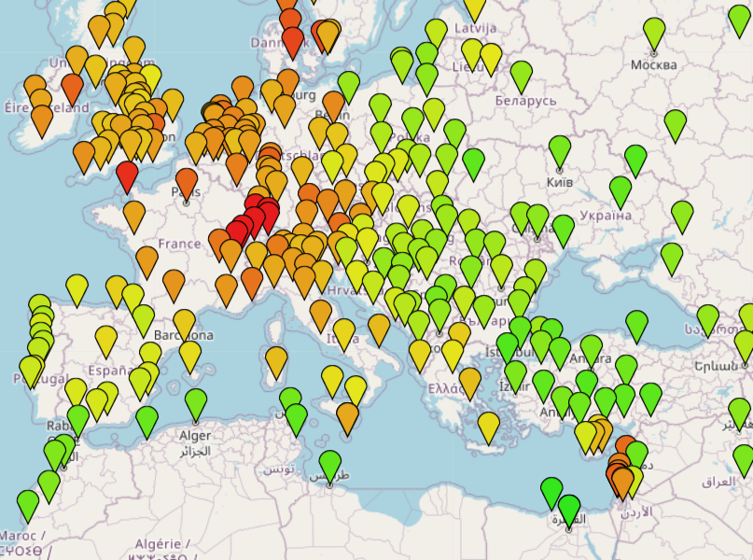

Figure 7: Dense area of data points in Numbeo

In addition, some users may not know the location of the city they want to select, making it more difficult for them to correctly pick the point and view the detailed information.

### Suggestion

In order to make the map easier to examine, a search bar should appear on the top of the visualization web page, allowing the users to search for the location that they want. After searching, Numbeo will automatically zoom in to the desired location. This will greatly assist new users in obtaining information. (Figure 8)

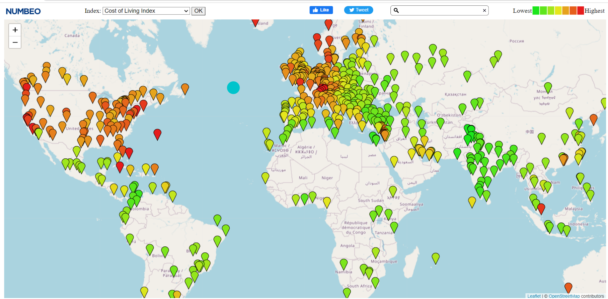

Figure 8: Numbeo page with a search bar

Moreover, tooltips can be used to address the problems caused by the dense area of location points. It will appear when the user moves the mouse over a data point, which will display the location's name, its coordinates, and the country to which the location belongs, allowing the user to conveniently distinguish and select the desired cities.

## Visualization 2: A breakdown of the rising cost of living in UK

### Context

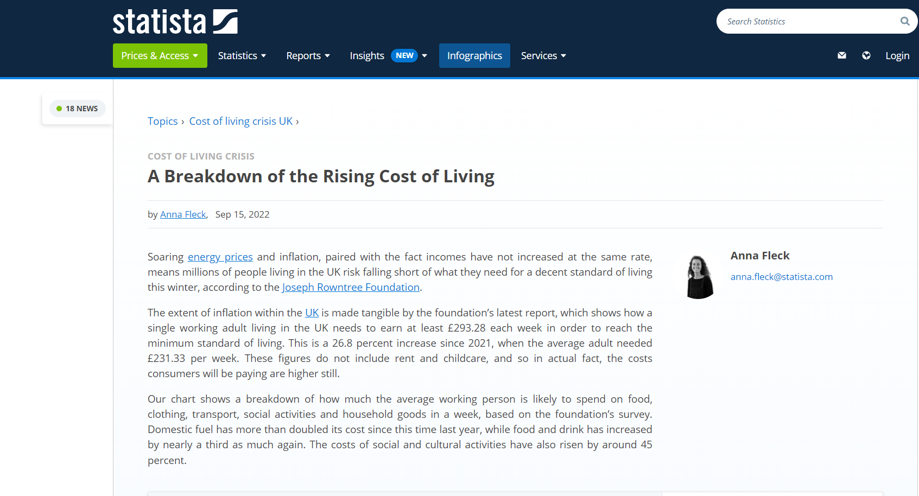

Figure 9: A Breakdown of the Rising Cost of Living by Statista (Fleck, 2022)

This chart is on a webpage called Statista from September 2022, which is a breakdown of the cost of living of an average working person in the UK. The target audience of this visualization is both the general public and people in the economic industry, so it is very straightforward to comprehend and examine.

### Visual analysis

The chart is a bar chart depicting the categorical attributes of the living costs, such as Travel and domestic fuel, along with their corresponding quantitative data values - the cost in £. Each attribute has two bars, encoded with two distinct colors, representing the years 2021 and 2022. (Figure 10)

Figure 10: A breakdown of the rising cost of living in UK

In addition, a summary of the figure is presented in the bottom right corner of the chart, providing users with an overview of the comparison result. (Figure 11)

Figure 11: Summary of the breakdown

### Critique

The use of two columns, one for each year 2021 and 2022, with labels and cost values at the top of the bar columns, makes the visualization very efficient for users in highlighting the difference and similarities between the two years. For example, by comparing the length of the bar columns and the numbers at the top (£57.09 and £74.06), users can easily compare the average cost of food and drink over the two years. In addition, the graph does not contain unnecessary x and y axes since the data value for each attribute has already been written on the top of the bar, thereby improving the data-to-ink ratio of the visualization.

The problem with the graph, on the other hand, is that the font color is unsuitable. The use of a red color for the year 2021 and a red-brown color for the year 2022 does not create a clear distinction between the two figures. In a visualization that encourages the readers to compare and contrast like the bar chart, color selection is very critical. It should be suitable, vibrant and can help the users easily compare the figures. The graph, however, does not satisfy this requirement.

### Suggestion

A complementary combination of font colors, such as red and blue, red and green, or purple and yellow, can be utilized to enhance the performance of the graph. Combining a pair of complementary colors creates a high contrast effect, which makes it simpler for users to identify differences. In addition, this graph may include an interactive feature that when the user moves the mouse pointer over or clicks on a cost category such as Food and Beverage, the field is highlighted, which greatly improves the interactivity of the visualization and makes it easier for the user to compare the figures of each field.

## Visualization 3: CPI inflation rate in UK

### Context

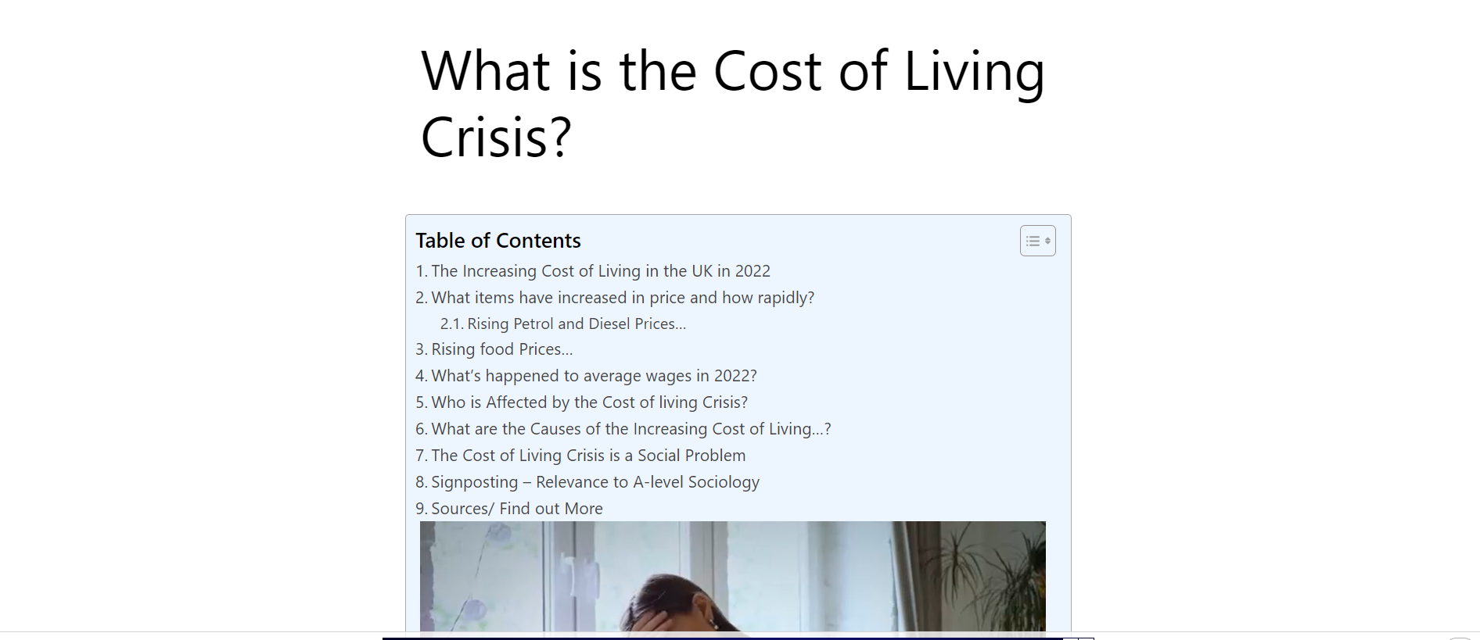

Figure 12: What is the Cost of Living Crisis (ReviseSociology)

The final visualization is from a webpage titled “What is the cost of living crisis”, which shows the rate of CPI inflation rate in the UK from August 2020 to August 2022. This graph is designed for business analysts and economists who want to enhance the decision-making processes and operations of their companies, as well as for entrepreneurs who wish to enter the market.

### Visual analysis

Figure 13: Contribution to annual CPI inflation rate, UK, August 2020 to August 2022

Over time, the CPI witnesses a general upward trend as depicted by the graph. The chart is a combination of a stacked bar and line chart, with the x-axis representing the time period and the y-axis displaying the quantitative data, which is the percentage point of the CPI rate. The line represents the overall rate of change in the CPI over time, whereas the columns of the bar chart are subdivided into many parts, each encoded with a different color, and show the detailed percentage point of various categories such as Clothing and Footwear, Transportation,…

### Critique

The usage of stacked bar and line graph is extremely effective. It can simultaneously display multiple attributes, such as the overall trend and the change of CPI in each category over time. There are labels at the top of the visualization to aid users in comparing the categories.

On the other hand, the issue with font color still appears in this visualization. The label and bar columns for the categories such as Food and non-alcoholic beverages, alcohol and tobacco, clothing and footwear are not easily distinguishable as the colors look very similar to each other.

However, the layout and design of the stacked bar chart is the most problematic aspect of this visualization. There are too many categories for the chart, causing the bars to be too tiny and thin, particularly for those with a small percentage point (Figure 14). This issue can affect the precision of data comparisons. Additionally, there is an issue with reading and analyzing from different categories. This is due to the fact that the bars are stacked on top of one another and when the data figures are relatively the same or close in value (Figure 15), it can be challenging to compare the size of each category over time or between various groups, leading to misinterpretations of the data.

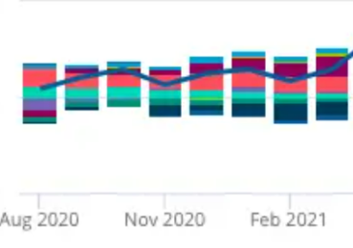

Figure 14: Small and thin bars with points that have small values

Figure 15: Bars with a similar size

However, on the other hand, the title of the chart is used efficiently. It is not very long but it still provides sufficient information for the users to acknowledge the overview of the graph. The line graph being used is also very efficient, which precisely represents the CPI rate over time and the fluctuation of the data.

### Suggestion

As I have mentioned, the chart witnesses some problems with color selection. Therefore, applying complementary colors can be a way to solve the problem. Furthermore, changing the size of the bars is also recommended to make it easier to examine. Additionally, interactive features can be applied in this chart. When the users hover over a bar, the bar should be highlighted and a tooltip containing the data value for each category should be displayed. This can help make the process of interpreting and comparing the bars much easier and more accurate.

# Conclusion

In conclusion, in these modern days and ages, when humanity has access to a high volume of data and information, utilizing charts and graphs is one of the greatest ways to represent and analyze them. However, not all data visualizations are good enough to use. To be considered an effective data visualization, Numerous factors are needed to be considered such as the choice of chart used, layout and design, the color, the label and the intended purpose of the chart. Three visualizations relating to Cost of Living have been evaluated in this report. Each of them has its good features and weaknesses. The first map visualization is, in my opinion, the most effective visualization in terms of design and data representation. In order to reach a wider audience, particularly those who are color-blind, the second and third visualization must be enhanced, particularly in terms of color usage.

# Reference

Fernando, J. (2023). *Consumer Price Index (CPI) Explained: What It Is and How It's Used*. <https://www.investopedia.com/terms/c/consumerpriceindex.asp#:~:text=The%20Consumer%20Price%20Index%20measures,markets%2C%20businesses%2C%20and%20consumers>

Fleck, A. (2022). *A Breakdown of the Rising Cost of Living*. <https://www.statista.com/chart/28262/breakdown-of-the-rising-cost-of-living-in-the-uk/>

*Numbeo*. <https://www.numbeo.com/cost-of-living/gmaps_rankings.jsp>

ReviseSociology. *What is the Cost of Living Crisis?* <https://revisesociology.com/2022/10/06/what-is-the-cost-of-living-crisis/>